### **Purpose of @SpringBootApplication Annotation**

The @SpringBootApplication annotation is a core component in Spring Boot applications and is placed above the main class, such as in SpringLearnApplication.java: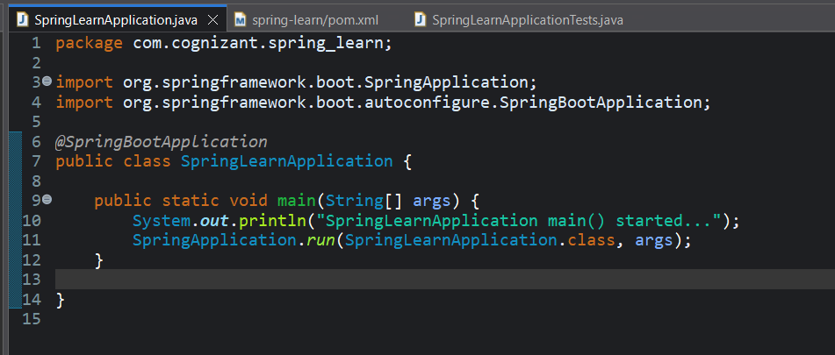

This annotation serves as a meta-annotation, combining three key annotations that are fundamental to configuring and launching a Spring Boot application. These include:

#### **1. @Configuration**

This annotation indicates that the class provides Spring configuration. It acts as a replacement for traditional XML-based configuration files by allowing Java-based configuration through annotated classes.

#### **2. @EnableAutoConfiguration**

This enables Spring Boot’s auto-configuration mechanism, which attempts to automatically configure the application based on the dependencies present in the classpath. For example, if Spring Web is present, it auto-configures an embedded Tomcat server. This feature significantly reduces the amount of manual configuration needed.

#### **3. @ComponentScan**

This instructs Spring to scan the current package and its sub-packages for components annotated with @Component, @Controller, @Service, @Repository, etc. This enables automatic registration of beans into the Spring application context.